Wildr FPS Profiling report.

What is FPS in Flutter?
Flutter aims to maintain a constant 60 FPS (Frames Per Second) for a smooth user interface.
- Frame Rendering:
  - Flutter renders each frame within 16ms (1 second ÷ 60 frames ≈ 16.67ms).
  - If any frame takes longer than 16.67ms to render, Flutter skips that frame and moves to the next one to maintain responsiveness.
  - While the FPS might stay at 60, the user may notice stutters as skipped frames interrupt smooth transitions.

Real-Time Responsiveness
Flutter prioritizes staying responsive over rendering delayed frames. Waiting for a slow frame to finish would further delay subsequent frames, resulting in a worse user experience. By skipping frames, Flutter ensures animations and interactions feel fluid.

What is Jank?
Jank refers to visible stutters or inconsistent frame rates caused by skipped frames or other performance issues.
- Cause: Frames taking longer than 16.67ms to render.
- Effect: The app appears to stutter, compromising the smooth user experience.

UI and Raster Rendering
Flutter’s rendering pipeline transforms code into visuals displayed on the screen. This pipeline has two major phases:
- UI Rendering: Builds the app's structure and layout.
- Raster Rendering: Converts the layout into displayable pixels.

Parallel Execution
- The UI Thread handles UI rendering.
- The Raster Thread handles raster rendering.
These processes run parallelly but depend on each other for sequential completion.

1. UI Rendering
This phase involves three sub-phases:

a. Build Phase
- What Happens:
  - Flutter constructs or updates the widget tree by calling build() methods.
  - This step determines what needs to be displayed (not where or how).
- Performance Challenges:
  - Deeply nested widget trees or unnecessary widget rebuilds can slow down this phase.

b. Layout Phase
- What Happens:
  - Flutter calculates the size and position of each widget.
  - This ensures widgets are properly placed with correct boundaries.
- Key Tasks:
  - Measure: Determine widget dimensions (height and width).
  - Position: Decide widget placement on the screen.
- Performance Challenges:
  - Complex hierarchies or dynamic sizing can prolong this phase.

c. Paint Phase
- What Happens:
  - Flutter generates drawing instructions for visual elements (shapes, colors, text).
  - These commands form a LayerTree, which is passed to the raster thread.
- Key Tasks:
  - Drawing shapes, text, and images.
  - Applying effects like gradients, shadows, or clipping.
- Performance Challenges:
  - Overuse of effects or overlapping transparent layers can slow down painting.
Note: If UI rendering exceeds 16.67ms, it results in UI jank.

2. Raster Rendering
This phase processes the LayerTree to create GPU-ready pixels for display. The main tasks include:
- Shader Compilation
- Other Raster Work

a. Shader Compilation
- What Happens:
  - Shaders are small GPU programs that create visual effects (e.g., shadows, gradients).
  - Shader compilation prepares these programs for GPU use.
- Challenges:
  - Compilation is GPU-intensive and, when done during runtime, may cause shader jank if it exceeds 16.67ms.
- When It Happens:
  - Typically during the first use of effects or animations.
- Solutions:
  - Precompile Shaders: Use SkSL warm-up to compile shaders at startup.
  - Warm Up Effects: Trigger animations in the background to compile shaders early.
  - Simplify Effects: Avoid heavy effects unless necessary.

b. Other Raster Work
This includes tasks like:
- Compositing Layers: Combining layers into a single image.
- Tiling: Breaking large visuals into smaller tiles for efficient rendering.
- Bitmap Decoding: Converting image files into pixel data.
- Applying Effects: Adding clipping, transformations, or blending.
Note:
Raster Jank:
- This occurs when any part of the raster rendering process (including shader compilation, compositing, tiling, etc.) takes longer than 16.67ms.
- Raster jank includes shader compilation but is not limited to it.
Shader Jank:
- A specific type of raster jank caused exclusively by shader compilation taking longer than 16.67ms.

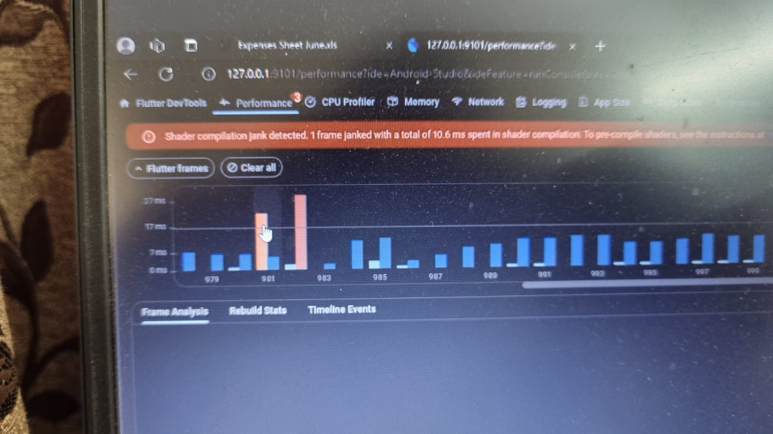

Here on performance tab of flutter devtools

Each frame is shown by a pair of UI rendering and Raster rendering
- UI rendering(left in the pair) - Light blue vertical line<16.6ms<Orange vertical line
- Raster rendering(right in the pair) -Dark blue vertical line<16.6ms<Red vertical line

If either one crosses the mark of 16.6ms then the frame will be skipped.

Shader compilation(will be part of right pair only that is raster rendering part)-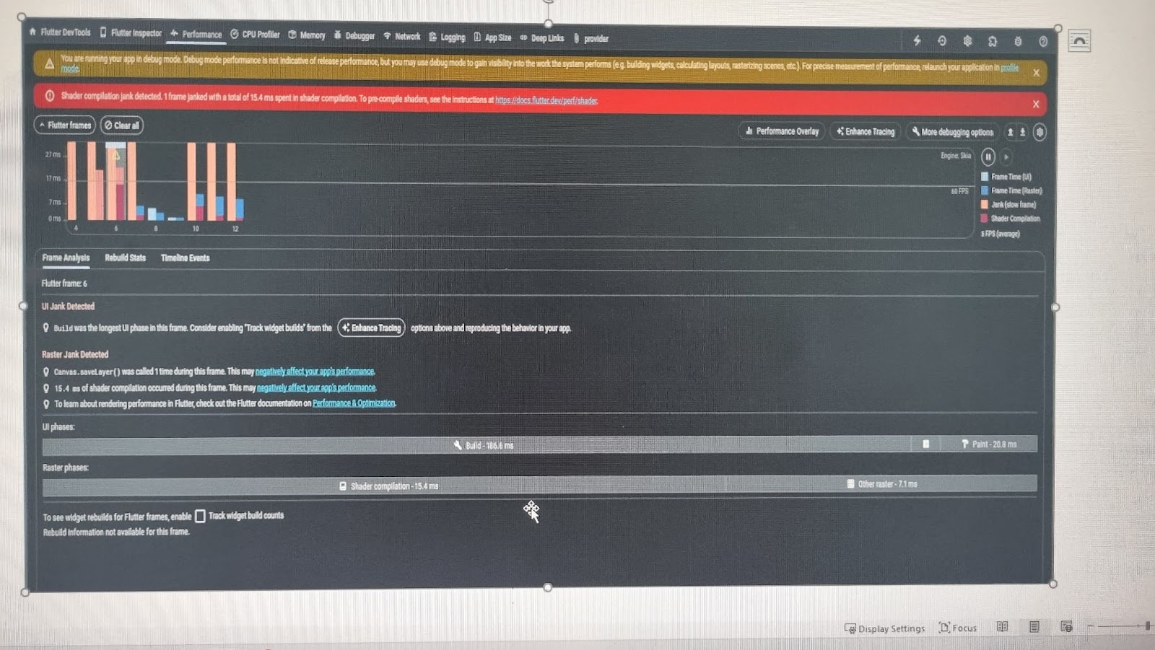
dark red >16.6ms>dark red

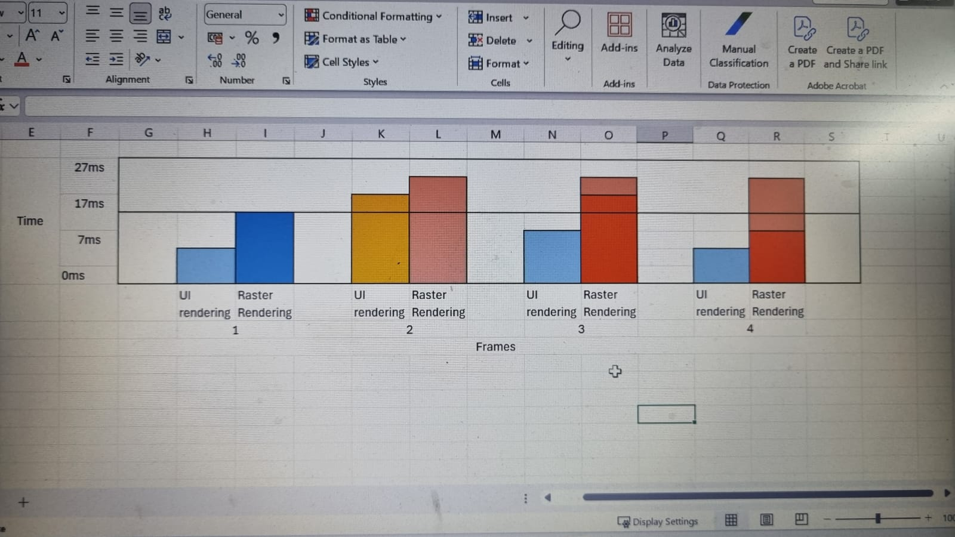

1. Frame 1 - both UI and raster rendering are within time limit
2. Frame 2 - both are above limit so there is UI jank as well as raster jank. But here there in no
Shader compilation occurred
3 Frame 3 - UI rendering is under limit but the raster rendering is above limit wherein the shader compilation itself is out of limit so its a shader jank.

4 Frame 4 - here UI rendering is in limit and raster rendering is out of limit but here shader compilation is not above limit so it's not a shader jank but mere a raster jank.

________________________________________________________________________________________________________________________________________________________

